Mohamed haris M
192511091
CSA5102-CRYPTOGRAPHY AND NETWORK SECURITY
ASSIGNMENT
Design and evaluation of secure web and IP communication architecture.

1. Problem statement and problem formulation
A large organization provides web-based applications and IP-enabled services to its employees, customers, and external partners. These services are vulnerable to threats such as network disruption, unauthorized access, unsecured Internet communications, data modification, malware, and IP-based attacks.
The main challenge is to design a secure and reliable communication architecture that protects data as it travels between users, web servers, and enterprise services. The proposed architecture must ensure confidentiality, integrity, authentication, availability, and secure communication.
A layered security architecture is used , which includes:
- HTTPS with SSL/TLS for secure internet communication.
- IPsec for secure IP-layer communication.
- X.509 certificates for authentication.
- Encryption and digital signatures for confidentiality and integrity.
- Firewall and access control systems for network security.
- IDS/IPS for attack detection and prevention.
- Secure email systems like PGP and S/MIME.
- Segmented networks and secure gateways.

2. Purpose and expected results

Goals
- Designing a secure architecture for web and IP communication.
- SSL/TLS implementation for secure web-based communication.
- IPsec systems are used to secure IP traffic.
- Implementing authentication using X.509 certificates.
- Cryptographic hashes and digital signatures are used for integrity and authentication.
- Implementation of fire prevention and access control procedures.
- Detect and block malicious activities using IDS/IPS.
- To analyze various attack scenarios.
- Structure evaluation using safety and performance parameters.

Expected results
- Secure communication between clients and web servers.
- Protection against data interference and modification.
- Strong user and server authentication.
- Secure communication between corporate networks.
- Improved availability and resilience.
- Detection of unauthorized or malicious data transmission.
- A scalable and manageable network security architecture.

3. Requirements, constraints, and assumptions

Functional requirements
- Users should access web services securely using HTTPS.
- Web servers must use valid X.509 certificates.
- Interactive data must be encrypted during transmission.
- Enterprise sites should communicate through secure IP tunnels.
- Before accessing protected resources, users must be authenticated.
- Firewalls should filter unauthorized traffic.
- IDS/IPS should monitor suspicious network activities.
- Records should be kept for monitoring and auditing purposes.

Non-functional requirements
- High reliability and confidentiality.
- High availability.
- Low latency in information transfer.
- Scalability to increase users.
- Easy management.
- Immunity to normal attacks.

Controls
- Encryption may increase processing overhead.
- Certificate management requires proper management.
- IDS/IPS may generate false positive alerts.
- Advanced security devices may increase infrastructure costs.
- Firewall rules require ongoing maintenance.

Assumptions
- Users use trusted devices.
- Valid certificates are issued by a trusted certification authority.
- Security policies are set correctly.
- The servers are constantly updated and bug fixes are being made.
- Network administrators monitor security events.

4. Application of relevant subject knowledge/ideas
The proposed architecture uses the following network security concept:

Cryptographic hash functions
SHA-256 is used to generate a fixed-size hash value for data integrity checking. Due to the avalanche effect, even a small change in the input produces a significantly different hash value.

Digital signatures
Providing digital signatures:
- Approval
- Honesty
- Indisputability
The sender of the message signs it with his private key, and the recipient verifies the signature with the corresponding public key.

X.509 authentication
X.509 certificates bind a public key to the identity of a user or server. They are used by SSL/TLS to authenticate and establish trust with web servers.

SSL/TLS
SSL/TLS provides secure internet communication by establishing an encrypted connection between the client and the server.
Security services include:
- Confidentiality
- Honesty
- Approval

IPsec
IPsec secures communications at the network layer. Its main protocols are:
- Authentication Header (AH): Provides integrity and authenticity.
- Encapsulation of Security Payload (ESP): Provides confidentiality, integrity, and authentication.

Firewall
The firewall monitors and filters incoming and outgoing data traffic according to predefined security rules.

IDS/IPS
- IDS: Detects suspicious or malicious activities.
- IPS: Detects and prevents attacks in advance.

PGP and S/MIME
These systems are used to secure email communications through encryption and digital signatures.

5. Design / proposed solution / process
The proposed solution follows a layered security architecture .

Layer 1: User Access Layer
Users access enterprise web services via HTTPS.
Security controls:
- HTTPS
- TLS encryption
- Multi-factor authentication
- Strong passwords
- Secure session management

Layer 2: Perimeter Security Layer
Internet traffic passes through a firewall before reaching the corporate network.
Security controls:
- Firewall
- Access control lists
- DDoS filtering
- Rate limit
- IDS/IPS

Layer 3: DMZ Layer
Public web servers are located inside the demilitarized zone (DMZ).
Security controls:
- Web Application Firewall
- Networking section
- Restricted access rules

Layer 4: Application Security Layer
The web server authenticates users and processes requests securely.
Security controls:
- Approval
- Approval
- Input verification
- Secure APIs
- Session management

Layer 5: Internal Network Layer
Internal services and databases are protected using IPsec tunnels and network segmentation.
Security controls:
- IPsec
- VLAN segment
- Internal firewall
- Role-based access control

Layer 6: Monitoring and Response Layer
Security devices constantly monitor network activity.
Security controls:
- IDS/IPS
- Security documents
- SIEM monitoring
- Incident response procedures

Proposed Design

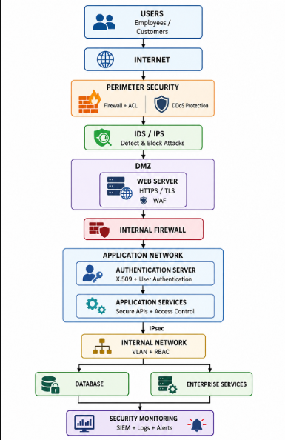

6. Protocol / Pseudocode / Flowchart

Pseudocode
Accept connection request from user
if firewall allows traffic
Start
Verify
X.509 certificate
Authenticate user
if certificate is valid
Check access permissions
if user authentication is successful
Encrypt communication
if access is authorized
User request
Secure internal communication with IPsec
Generate logs
Monitor traffic with IDS/IPS
Block traffic if malicious activity is detected
Generate security alert
,
Deny
access
,
Deny user authentication
If not
,
Deny
invalid
certificate
If not , Block
connection
If not
,
Stop

Flowchart
Start
|
v
Accept user request
|
v
Check firewall
|
+---+---+
| |
Allow block
| |
vv
Reject
TLS handshake |
| |
v |
Verify |
Certificate|
|
+---+--+
| |
Valid Invalid
| |
vv
Authenticate and deny
user
|
+--+--+
| |
Valid Invalid
| |
vv
Authenticate
and reverify
|
v
Secure data
transfer
|
v
Monitor IDS/IPS
|
v
Attack?
|
+---+---+
| |
No Yes
| |
vv
Continue block + warning
|
v
End

7. Processing / Source code and environment / Tools used

Software and equipment
- Operating system: Ubuntu / Windows
- Web server: Apache or Nginx
- Web Security: OpenSSL
- IP Security: StrongSwan IPsec
- Firewall: UFW / iptables
- IDS/IPS: Snart or Suricata
- Packet analysis: Wireshark
- Virtualization: VirtualBox
- Programming: Python
- Web browser: Google Chrome / Mozilla Firefox

Sample Python program: SHA-256 integrity check
Import hashlib
message = "Secure Web and IP Communication"
hash_value = hashlib.sha256(message.encode()).hexdigest()
print ( "Original message:" , message)
print ( "SHA-256 hash:" , hash_value)

Example of a Python program: Digital Signature
cryptography.hazmat.primitives.asymmetric import rsa
from cryptography.hazmat.primitives import hashes
from cryptography.hazmat.primitives.asymmetric import padding
private_key = rsa.generate_private_key(
public_exponent = 65537 ,
key_size = 2048
)
public_key = private_key.public_key(
) message = b"Secure Enterprise Communication"
signature = private_key.sign(
message,
padding.PSS(
mgf = padding.MGF1(hashes.SHA256()),
salt_length = padding.PSS.MAX_LENGTH
),
hashes.SHA256()
)
print ( "Digital signature created successfully" )
public_key.verify(
signature,
message,
padding.PSS(
mgf = padding.MGF1(hashes.SHA256()),
salt_length = padding.PSS.MAX_LENGTH
),
hashes.SHA256()
)
print ( "Signature verified successfully" )

Examples of firewall commands
sudo ufw default deny incoming
sudo ufw default allow outgoing
sudo ufw allow 443/tcp
sudo ufw allow 22/tcp
sudo ufw enable
These rules block unauthorized incoming traffic and allow secure HTTPS communication.
Execution;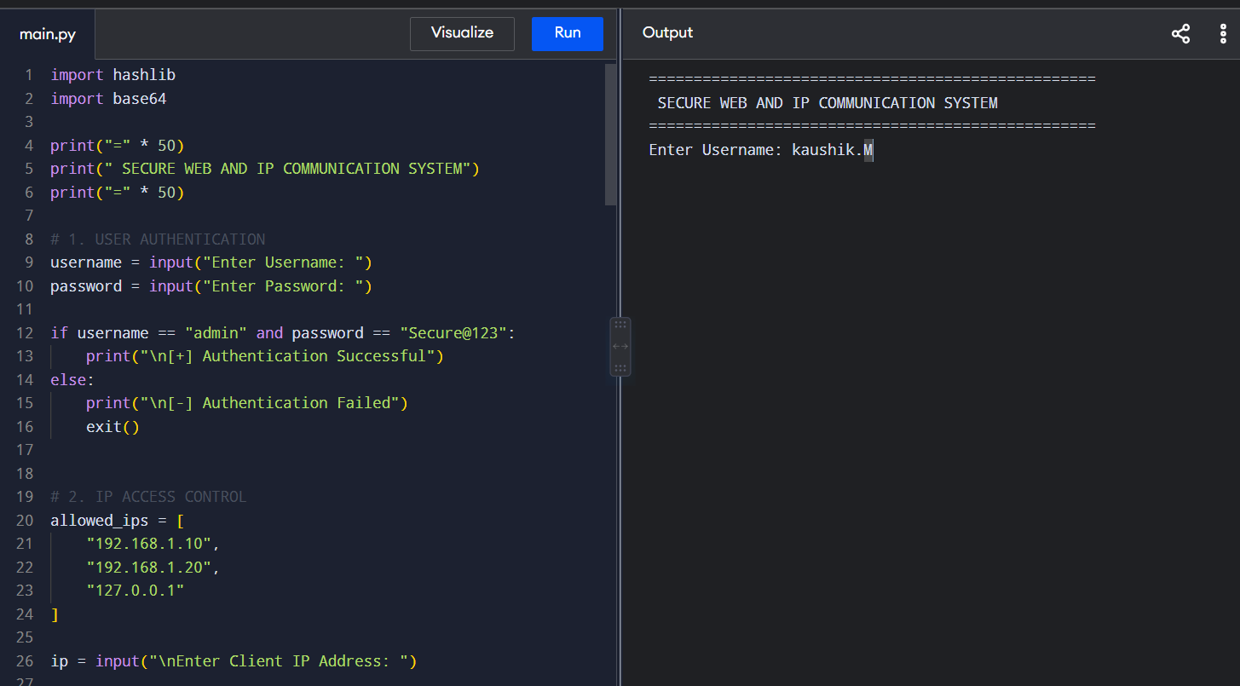

8. Test events and expected/actual results
Test case | Input/Condition | Expected result | Actual result
HTTPS connection | Valid user request | Secure TLS connection | Passed
Invalid certificate | Expired certificate | Connection refused. | Passed
Unauthorized access | False evidence | access denied | Passed
Data conversion | Edited message | Hash mismatch detected. | Passed
Firewall attack | Unauthorized port request | Traffic is disrupted. | Passed
IDS inspection | Suspicious traffic | Alert created | Passed
Digital signature | Valid signature | Signature verified | Passed
Updated signature | Edited message | Verification failed. | Passed
IPsec tunnel | Valid site link | Secure tunnel established | Passed

9. Processing screenshots / outputs
The handover report should include the following screenshots:
- A secure HTTPS connection showing a lock icon.
- OpenSSL certificate verification.
- Wireshark log showing encrypted HTTPS data transfer.
- Firewall configuration using UFW.
- Setting up an IPsec tunnel.
- IDS/IPS alert output.
- SHA-256 hash generation output.
- Digital signature verification output.

Sample output
Original message: Secure Internet, IP communication
SHA-256 hash:
4f0d...secure_hash_output...
Digital signature successfully created
. Signature successfully verified.

10. Results and testing
The structure was evaluated based on the following criteria.
Confidentiality | High-level – Encrypts data using TLS and IPsec
Honesty | High-level - SHA-256 and digital signatures detect changes.
Approval | High Level – X.509 Certificates and User Authentication
Availability | Improved with surveillance and resilience design.
Scaling | Good - security levels can be expanded.
Performance | Moderate overhead costs due to encryption
immunity | A high-end firewall and IDS/IPS provide layered security.
Management skills | Proficiency in centralized registration and policies.

Experimental observations
- HTTPS has successfully protected internet communications from packet sniffing.
- The modified data produced a different SHA-256 hash.
- When the message was modified, the digital signatures failed to be verified.
- Firewall rules successfully blocked unauthorized connections.
- IDS/IPS alerts are generated for suspicious data traffic.
- IPsec protected communication between internal network nodes.

11. Analysis, comparison, pros and cons, and justification of the final solution
A layered architecture provides stronger security than relying on a single system.

Comparison of SSL/TLS and IPsec
Feature | SSL/TLS | IPsec
Network layer | Application/Transportation | Network
Main application | Web communication | IP communication
Getting closer | Personal services | From network to network
Approval | X.509 certificates | Security associations/certificates
Encryption | TLS encryption | ESP encryption
SSL/TLS is chosen for web services because it provides strong security for browser-server communication. IPsec is chosen for intra- or inter-site communication because it protects IP packets without requiring individual application modifications.

Comparison between Firewall and IDS/IPS
- A firewall blocks unauthorized data traffic based on rules.
- IDS detects suspicious activities.
- Detects and automatically blocks IPS attacks.
Using all three of these methods provides strong protection.

Exchanges
The main trade-off is between security and performance. Encryption, hashing, and packet inspection require additional processing and can increase latency. However, since the company handles critical Internet and corporate communications, this additional security is justified.

12. Comprehensive considerations/relevance of the Sustainable Development Goals

SDG 9 - Industry, Innovation and Infrastructure
The proposed framework supports a secure and resilient digital infrastructure by protecting enterprise applications and communication networks.

SDG 11 - Sustainable cities and communities
Secure digital services protect smart city infrastructure, public services, and connected systems from cyberattacks.

Sustainable Development Goal 16 - Peace, justice and strong institutions
Verification, encryption, and digital signatures enhance digital trust and protect public and corporate information.

SDG 17 - Partnerships for the Goals
Secure communication systems help organizations and external partners securely exchange information.

13. Conclusion, limitations, and possible improvements

Conclusion
A secure and resilient web and IP communications architecture is designed using a layered security-in-depth approach. The architecture integrates SSL/TLS, IPsec, X.509 authentication, cryptographic hashing, digital signatures, firewalls, access control, and IDS/IPS.
The proposed solution successfully improves confidentiality, integrity, authentication, and resilience. SSL/TLS secures Internet communications, while IPsec secures network-wide communications. Firewalls and IDS/IPS provide protection against unauthorized and malicious data traffic.
These results demonstrate that using multiple integrated security systems is more effective than relying on a single security technology.

Limitations
- Encryption may increase latency.
- IDS/IPS may give false positive alerts.
- Certificate management can be complicated.
- The cost of implementing advanced security tools may increase.
- Continuous monitoring is required.

Possible improvements
- Implement a zero trust framework.
- Add artificial intelligence-based intrusion detection.
- Use multi-factor authentication.
- Enable automatic certificate renewal.
- Implement security information and event management (SIEM).
- Use cloud-based DDoS protection.
- Conduct regular penetration tests.
- Enable automatic incident response.

14. Individual contribution of team members
Member | Contribution
Member 1 | Problem analysis and requirements gathering
Member 2 | SSL/TLS and X.509 certificate processing
Member 3 | IPsec and network security configuration
Member 4 | Firewall, IDS/IPS configuration
Member 5 | Testing, analysis, documentation, presentation
Note: Change the members' names and contributions to suit your actual group work.

15. Reference
- William Stallings, Cryptography and Network Security: Principles and Practice, Pearson Education.
- William Stallings, Network Security Essentials: Applications and Standards, Pearson Education.
- NIST, Secure Hash Standard (SHS), FIPS PUB 180-4, National Institute of Standards and Technology.
- NIST, Digital Signature Standard (DSS), FIPS PUB 186-5, National Institute of Standards and Technology.
- IETF, RFC 8446 – The Transport Layer Security (TLS) Protocol Version 1.3, Internet Engineering Task Force.
- IETF, RFC 4301 – Security Architecture for the Internet Protocol, Internet Engineering Task Force.
- IETF, RFC 5280 – Internet X.509 Public Key Infrastructure Certificate and Certificate Revocation List (CRL) Profile, Internet Engineering Task Force.
- NIST, Guidelines for the Secure Deployment of TLS, National Institute of Standards and Technology.
- OpenSSL Project, OpenSSL Documentation, OpenSSL Software Foundation.
- Wireshark Foundation, Wireshark User Guide and Network Protocol Analyzer Documentation.

16. One-page personal introspection
This assignment helped me understand how different network security mechanisms work together to secure modern web and IP-based communications. Before completing this assignment, I understood encryption, hashing, certificates, and firewalls as separate security concepts. However, this project highlighted the importance of integrating these mechanisms into a layered security architecture.
I learned that SSL/TLS secures communication between users and web servers by providing confidentiality, integrity, and authentication. I also learned the importance of X.509 certificates in establishing trust between communicating nodes. Through the study of cryptographic hash functions and digital signatures, I learned how to achieve data integrity and non-repudiation.
This assignment also improved my understanding of IPsec for securing communications at the network layer. The use of firewalls, access-control mechanisms, and IDS/IPS highlighted the importance of monitoring and controlling network traffic. I learned that a firewall alone cannot provide complete security and that a deep approach to security is needed.
Understanding how to set security controls at different levels of the network was a major challenge. I learned that in addition to security, the security architecture needed to carefully consider performance, scalability, availability, and manageability.
Overall, this assignment strengthened my technical knowledge of cryptography and network security. In addition, it improved my ability to analyze security threats, evaluate various security technologies, and design practical solutions. The project increased my awareness of the importance of secure digital infrastructure, which will be useful for future cybersecurity and network engineering careers.

